ASSIGNMENT 2 – CO2

CO2 Coverage: Design C++ programs by applying functions and object-oriented concepts – function prototyping, call by reference, return by reference, inline functions, default arguments, function overloading, specifying a class, member functions, access specifiers, arrays within a class, static data members and member functions, arrays of objects and friend functions.
Name : Vaishnavi S
Register Number :192521313
Nature of Assignment: Individual
Duration: 1 Week
Total Marks: 50
Submission Date: 31/10/2026
Bloom’s Levels Assessed: K5 – Evaluate (every task in this assignment is at K5 level)
Mandatory Execution and GitHub Submission
- Every student must individually execute every task in this assignment, including all “Complete the Code” programs.
- Create a GitHub repository named DSA01-<RegisterNumber>-Assignment2 and
share it with the course faculty (public, or private with the faculty added as a collaborator).
- Keep one folder for each task (for example: Task01, Task02 … or Q1, Q2 …), containing the C++ source files, input files and output screenshots.
- Include a README.md with your name, register number, compiler and version (for example g++ 13), the exact g++ command used to compile (for example g++ -std=c++17 Wall -Wextra), the steps to run each program, and a short note of the result of each task.
- Commit your work progressively – at least one commit for each task. The commit history will be checked; a single upload of all files on the last day will not be accepted.
- Submit the GitHub link below and on the cover page of your report. An assignment submitted without a working GitHub link will not be evaluated.

GitHub Repository Link: https://github.com/vaish63804/C--192521313--Vaishnavi.S How to Answer the Additional Questions
Complete the Code: Copy the given code into your repository, replace every TODO with working code without changing the rest of the program, execute it and compare your output with the expected output.
Predict the Output: Write the exact output of the given program before running it. Then run it and explain every difference between your prediction and the actual output, using the C++ rules involved. Predictions written after running the program will not be credited.
Alternative Concept and Complexity Analysis: Describe how the solution would change if the alternative concept were used, with code or pseudocode, and analyse and compare the time complexity and space complexity of both solutions using Big-O notation, supported by your own measurements wherever possible.

Q1 – Call by Value, by Reference and by Pointer 6 Marks
Bloom’s Level: K5 – Evaluate
Problem Context – Hostel Fee Concession Updater
The hostel office applies concessions (merit 10%, sports 15%, single parent 25%) to students’ fees. A function written to apply the concession appears to work when its result is printed inside the function, but the fee stored for the student never changes.
Your Challenge
Write the concession function three ways – passing the fee by value, by reference and by pointer. Before running, predict the stored fee after each call, then verify.
Inquiry
Explain where each version stores its parameter, why only two of them change the caller’s fee, and when a const reference parameter should be used instead.
Design Decision
Several concessions may apply to one student. Decide whether the function should change the fee in place or return the new fee, and defend your choice.
Predict the Output
Write the exact output of the program below BEFORE running it. Then compile and run it, and explain every difference between your prediction and the actual output. #include

Code :

#include <iostream>
using namespace std;

void change(int a, int& b, int* c) {
a += 10;
b += 10;
*c += 10;
}

int& bigger(int& p, int& q) {
return p > q ? p : q;
}

void show(int x, int y = 5, int z = 10) {
cout << x + y + z << " ";
}

void applyByValue(long long fee, int percent) {
fee -= fee * percent / 100;
}

void applyConcession(long long& fee, int percent) {
fee -= fee * percent / 100;
}

void applyByPointer(long long* fee, int percent) {
if (fee != nullptr) {
*fee -= *fee * percent / 100;
}
}

int main() {
int a = 1, b = 2, c = 3;

change(a, b, &c);
cout << a << " " << b << " " << c << '\n';

bigger(a, c) = 100;
cout << a << " " << c << '\n';

show(1);
show(1, 2);
show(1, 2, 3);
cout << '\n';

long long hostelFee = 45000;

applyByValue(hostelFee, 10);
cout << "after call by value: " << hostelFee << '\n';

applyConcession(hostelFee, 10);
cout << "after call by reference: " << hostelFee << '\n';

long long sportsFee = 45000;
applyByPointer(&sportsFee, 15);
cout << "after call by pointer: " << sportsFee << '\n';

return 0;
}
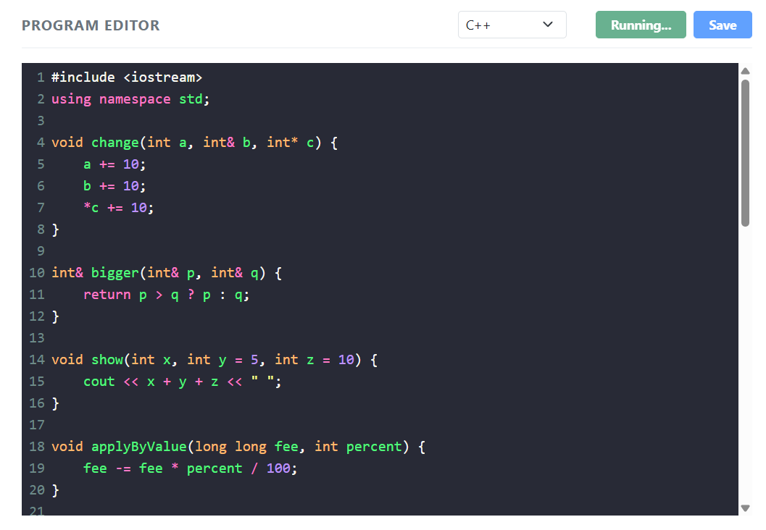

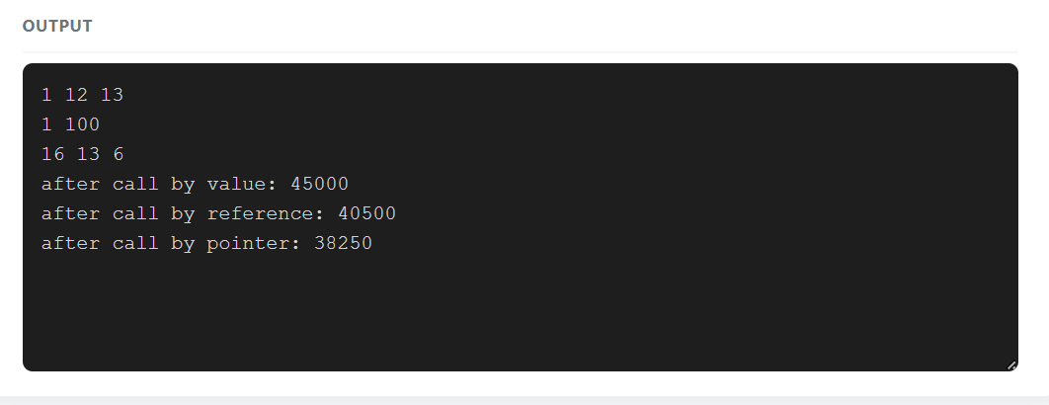

Q2 – Return by Reference and Its Dangers 4 Marks
Bloom’s Level: K5 – Evaluate
Problem Context – Examination Marks Register
The marks register keeps the marks of a class in an array. A function returns a reference to the highest mark so that a moderation of +2 can be applied directly to it. A second function returns a reference to a local variable.
Your Challenge
Implement both functions and show:
- How returning a reference lets the caller change the array element (and even use the call on the left of =)
- What the compiler warns about when a reference to a local variable is returned, and why using it is undefined behaviour
- The difference between returning a reference, returning a const reference and returning a copy

Changed Condition
The register is now stored in a std::vector that may grow. Explain why a reference obtained before the vector grows may become invalid.
Alternative Concept and Complexity Analysis
If the highest mark were returned as an index (int) or as a pointer (int*) instead of a reference
(int&), what would the calling code look like? Analyse the time to find the highest mark
(O(n) in all three) and the space (O(1)), and compare the safety of each when the array is later replaced by a growing vector.
Evidence Expected
Working functions, compiler-warning evidence, a correct explanation of dangling references and a justified response to the changed condition.
Code:
#include <iostream>
using namespace std;

int& highestMark(int marks[], int size) {
int highest = 0;

for (int i = 1; i < size; i++) {
if (marks[i] > marks[highest]) {
highest = i;
}
}

return marks[highest];
}

// Returning a reference to a local variable is unsafe.
// Do not call this function.
int& dangerousFunction() {
int value = 100;
return value; // Dangling reference: undefined behaviour
}

int highestIndex(const int marks[], int size) {
int highest = 0;

for (int i = 1; i < size; i++) {
if (marks[i] > marks[highest]) {
highest = i;
}
}

return highest;
}

int* highestPointer(int marks[], int size) {
int index = highestIndex(marks, size);
return &marks[index];
}

int main() {
int marks[] = {75, 88, 92, 81, 90};
int size = 5;

cout << "Original highest mark: "
<< highestMark(marks, size) << endl;

highestMark(marks, size) += 2;

cout << "After moderation: "
<< highestMark(marks, size) << endl;

highestMark(marks, size) = 100;

cout << "After direct assignment: "
<< highestMark(marks, size) << endl;

int index = highestIndex(marks, size);
cout << "Highest mark using index: "
<< marks[index] << endl;

int* ptr = highestPointer(marks, size);
cout << "Highest mark using pointer: "
<< *ptr << endl;

return 0;
}
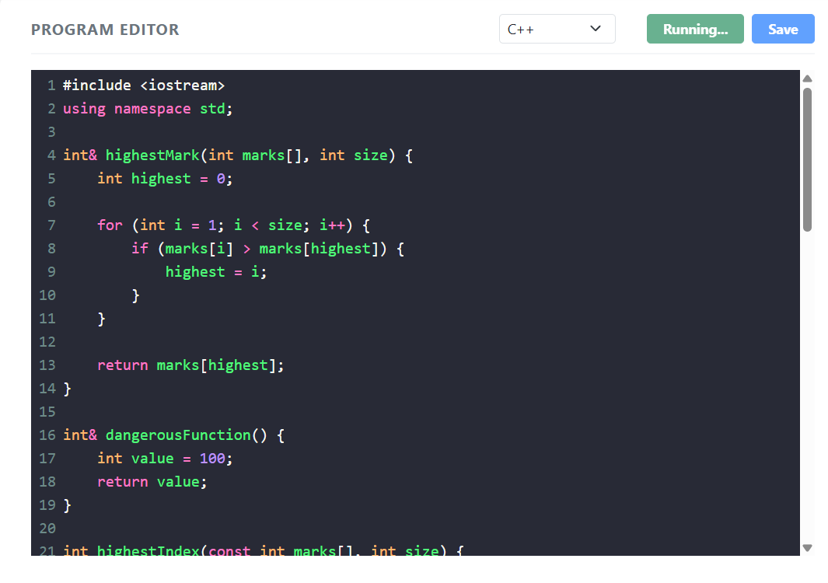

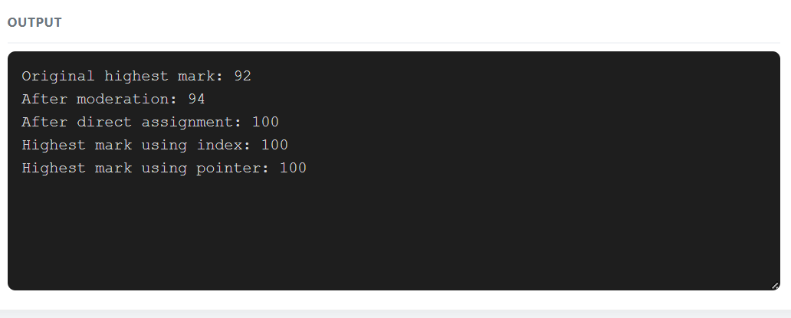

Q3 – Default Arguments and Function Overloading 6 Marks
Bloom’s Level: K5 – Evaluate
Problem Context – Courier Charge Calculator
A courier counter charges by weight; express delivery and insurance are optional. The developer wrote charge(double weight), charge(double weight, bool express) and charge(double weight, bool express = false, bool insured = false). The program no longer compiles.
Your Challenge
Explain the compiler error (ambiguous call). Then design the charge functions so that:
- Common calls are short (default arguments)
- Different kinds of input (weight in grams as int, weight in kg as double, a Parcel object) are handled by overloading
- No call is ambiguous

Before execution, predict which function each of six calls you design will select, including charge(2) and charge(2.0f).
Inquiry
Explain how the compiler chooses among overloaded functions (exact match, promotion, conversion), and why default arguments must be given from the right.
Alternative Concept and Complexity Analysis
If the courier charge took a single Parcel structure with optional fields (or a function template) instead of several overloaded functions with default arguments, what would the solution be? Analyse the time of overload resolution (at compile time, no run-time cost) and the space copied per call, and compare how each design handles a new option.
Code:
#include <iostream>
using namespace std;

struct Parcel {
double weight;
bool express;
bool insured;
};

double charge(double weight,
bool express = false,
bool insured = false) {
double amount = weight * 50;

if (express)
amount += 100;

if (insured)
amount += 50;

return amount;
}

// Weight in grams
double charge(int grams) {
return (grams / 1000.0) * 50;
}

// Parcel object
double charge(const Parcel& p) {
return charge(p.weight, p.express, p.insured);
}

int main() {
cout << "charge(2): "
<< charge(2) << endl;

cout << "charge(2.0): "
<< charge(2.0) << endl;

cout << "charge(2.0f): "
<< charge(2.0f) << endl;

cout << "charge(2000): "
<< charge(2000) << endl;

cout << "charge(2, true): "
<< charge(2.0, true) << endl;

Parcel p = {2.0, true, true};

cout << "charge(Parcel): "
<< charge(p) << endl;

return 0;
}
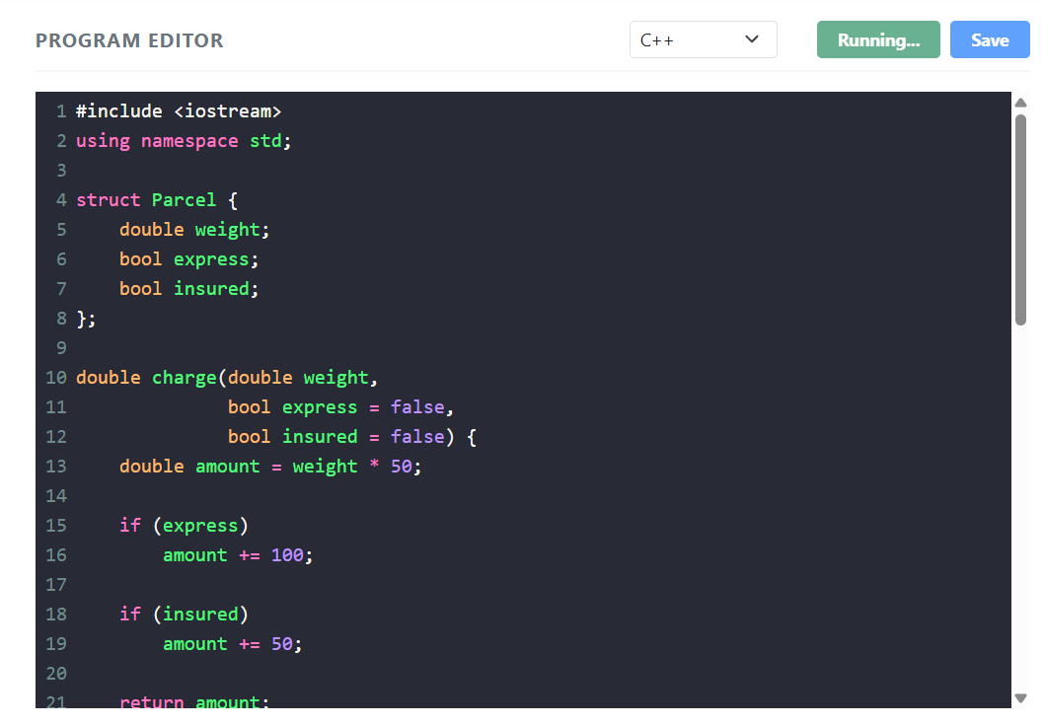

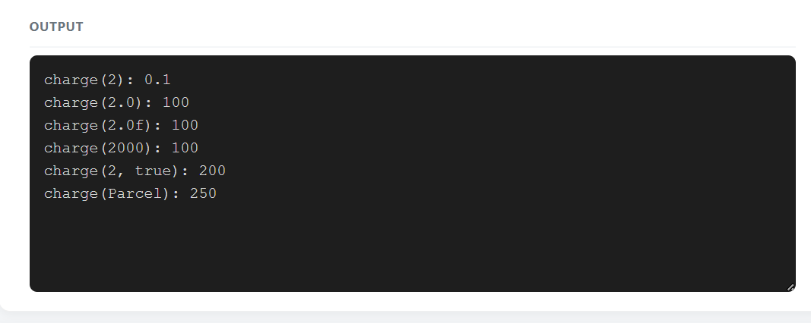
Q4 – Specifying a Class with an Array Inside It 6 Marks
Bloom’s Level: K5 – Evaluate
Problem Context – Savings Account Mini-Statement
A bank wants each SavingsAccount object to remember its last 10 transactions for the ministatement printed at an ATM. Older transactions are discarded.
Your Challenge
Specify the class with private data (account number, balance, an array of 10 transactions and a count) and public member functions deposit(), withdraw() and miniStatement(). Define some member functions inside the class and some outside using the scope resolution operator.
Inquiry
Explain why the array must be private, what happens when the 11th transaction arrives if you shift the array versus use a circular index, and the cost of each.
Design Decision
The bank now wants the last 50 transactions. Decide which design changes least and defend it.
Alternative Concept and Complexity Analysis
If the last 10 transactions were kept in a std::deque (push_back and pop_front), or in a circular buffer with a start index, instead of shifting a fixed array, what would the solution be? Analyse the time to add a transaction (O(k) for shifting k elements versus O(1)) and the space used in each design.
Code:
#include <iostream>
#include <iomanip>
using namespace std;

class SavingsAccount {
private:
long long accountNumber;
double balance;
double transactions[10];
int count;
int start;

void addTransaction(double amount) {
int position;

if (count < 10) {
position = (start + count) % 10;
count++;
} else {
position = start;
start = (start + 1) % 10;
}

transactions[position] = amount;
}

public:
SavingsAccount(long long accNo, double initialBalance)
: accountNumber(accNo),
balance(initialBalance),
count(0),
start(0) {
}

void deposit(double amount) {
if (amount <= 0) {
cout << "Invalid deposit" << endl;
return;
}

balance += amount;
addTransaction(amount);
cout << "Deposited: Rs " << amount << endl;
}

void withdraw(double amount) {
if (amount <= 0 || amount > balance) {
cout << "Invalid withdrawal" << endl;
return;
}

balance -= amount;
addTransaction(-amount);
cout << "Withdrawn: Rs " << amount << endl;
}

void miniStatement() const;

void showBalance() const {
cout << "Account Number: " << accountNumber << endl;
cout << "Balance: Rs " << balance << endl;
}
};

void SavingsAccount::miniStatement() const {
cout << "\nLast Transactions\n";

for (int i = 0; i < count; i++) {
int position = (start + i) % 10;

if (transactions[position] >= 0) {
cout << "Deposit: Rs "
<< transactions[position] << endl;
} else {
cout << "Withdrawal: Rs "
<< -transactions[position] << endl;
}
}
}

int main() {
SavingsAccount account(123456, 5000);

account.deposit(1000);
account.withdraw(500);
account.deposit(2000);
account.withdraw(300);

account.showBalance();
account.miniStatement();

return 0;
}
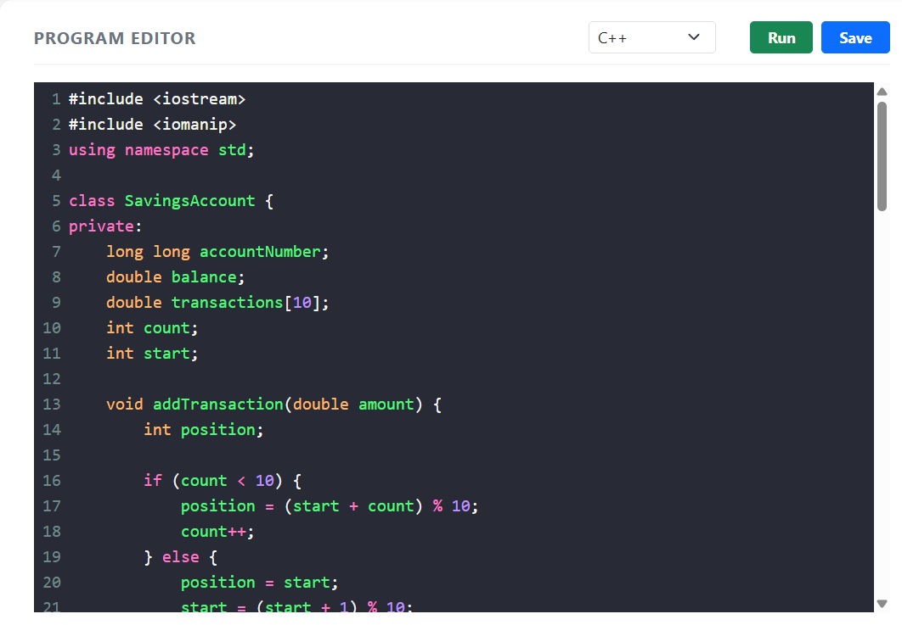

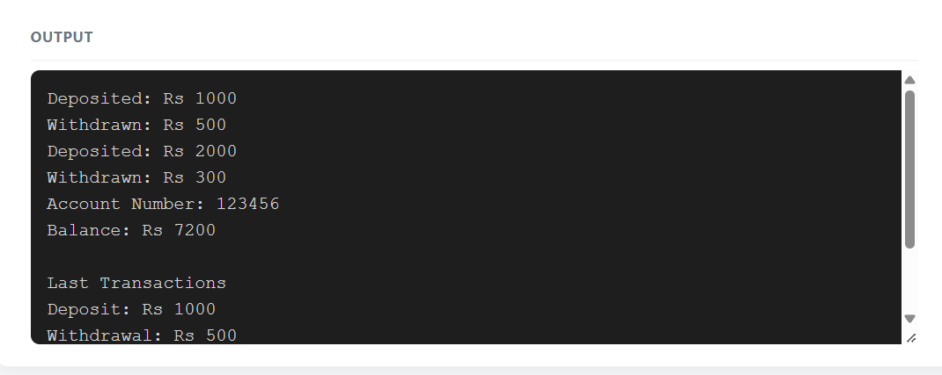
Q5 – Static Members and Arrays of Objects 7 Marks
Bloom’s Level: K5 – Evaluate
Problem Context – College Bus Seat Tickets
The college bus has a fixed number of seats. Each BusTicket object must receive the next seat number, tickets beyond the capacity go to a waiting list, and the transport office must know how many seats have been issued without looking at any particular ticket.
Design Starting Point
You are given only the following principle:
Data that belongs to the whole class – not to any one object – should exist only once, however many objects are created.
Your Challenge
Convert this principle into a class design. Determine:
- Which members must be static, and where a static data member must be defined
- Why a static member function cannot use this or a non-static member
- How an array of BusTicket objects is created and initialised
- What happens to the count when tickets are created inside a loop or a function

Test Your Design
Create an array of tickets larger than the capacity and verify the seat numbers and the waiting list.
Predict the Output
Code:
#include <iostream>
#include <string>
using namespace std;

class BusTicket {
private:
static int issued;
static const int CAPACITY = 3;

int seat;
string name;

public:
explicit BusTicket(const string& n)
: seat(0), name(n) {

if (issued < CAPACITY) {
issued++;
seat = issued;
}
}

static int count() {
return issued;
}

void print() const {
cout << name << ": ";

if (seat != 0)
cout << "Seat " << seat;
else
cout << "Waiting";

cout << '\n';
}
};

int BusTicket::issued = 0;

void createTickets() {
BusTicket tickets[] = {
BusTicket("Asha"),
BusTicket("Bala")
};

for (const BusTicket& t : tickets) {
t.print();
}

cout << "Total issued: " << BusTicket::count() << endl;
}

int main() {
BusTicket trip[4] = {
BusTicket("Asha"),
BusTicket("Bala"),
BusTicket("Chitra"),
BusTicket("Dev")
};

for (const BusTicket& t : trip) {
t.print();
}

cout << "Issued: " << BusTicket::count() << endl;

cout << "\nCreating more tickets:\n";
createTickets();

return 0;
}
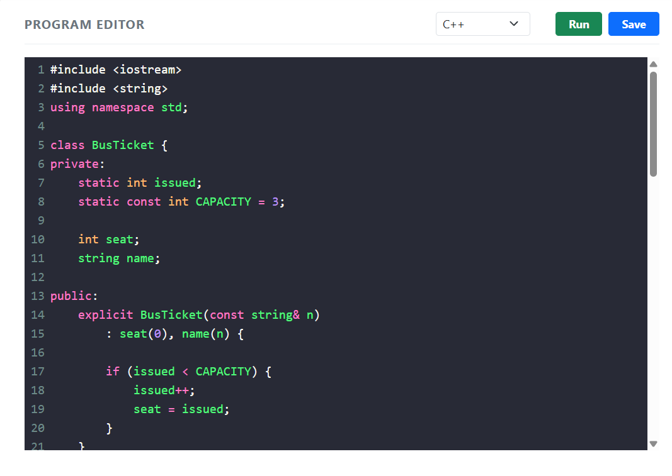
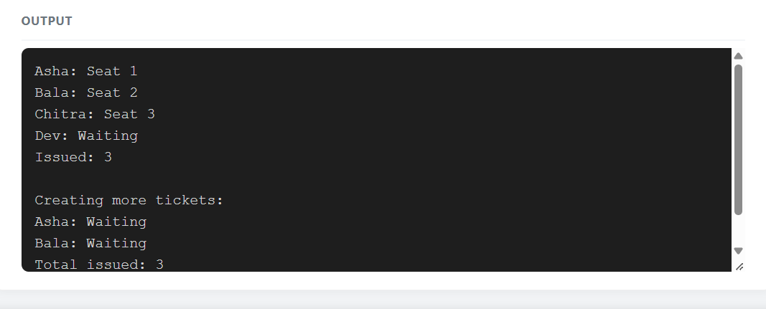
Q6 – Friend Functions and Inline Functions 8 Marks
Bloom’s Level: K5 – Evaluate
Problem Context – Train Journey Planner
A journey planner stores departure and arrival times in a Time class whose hours and minutes are private. It must compute the minutes between two times and decide which time is earlier, and these small functions are called millions of times while planning connections.
Your Challenge
Design the comparison. Determine:
- Why a friend function is needed when the function works on two objects equally
- How a friend function differs from a member function in how it is called and what it can access
- Whether the small functions should be inline, and what inline actually asks the compiler to do
- What would be lost if the private members were made public instead

Correctness Check
Test with times on either side of noon and the same time twice, and verify by hand.
Growth Investigation
Measure the time for 10,000,000 calls with and without inline (compile with -O0 and with O2), and explain the result.
Deployment Decision
Decide whether the friend functions should stay or be replaced by member functions and getters, and defend your decision.
Code:
#include <iostream>
using namespace std;

class Time {
private:
int h, m;

public:
Time(int hh, int mm) : h(hh), m(mm) {}

friend inline int minutesBetween(
const Time& a, const Time& b
);

friend inline bool earlier(
const Time& a, const Time& b
);
};

inline int minutesBetween(const Time& a, const Time& b) {
int first = a.h * 60 + a.m;
int second = b.h * 60 + b.m;

return (first > second)
? first - second
: second - first;
}

inline bool earlier(const Time& a, const Time& b) {
int first = a.h * 60 + a.m;
int second = b.h * 60 + b.m;

return first < second;
}

int main() {
Time departure(9, 45);
Time arrival(13, 10);

cout << minutesBetween(departure, arrival) << " "
<< boolalpha
<< earlier(arrival, departure) << endl;

Time morning(11, 30);
Time afternoon(12, 30);

cout << "Minutes between times: "
<< minutesBetween(morning, afternoon) << endl;

cout << "Morning is earlier: "
<< earlier(morning, afternoon) << endl;

Time same1(10, 30);
Time same2(10, 30);

cout << "Same time difference: "
<< minutesBetween(same1, same2) << endl;

cout << "Same time comparison: "
<< earlier(same1, same2) << endl;

return 0;
}
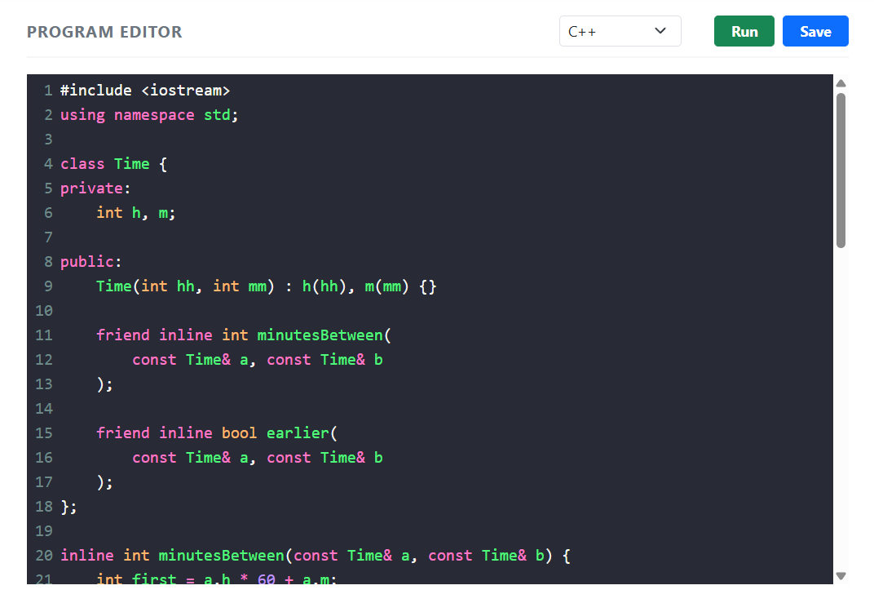

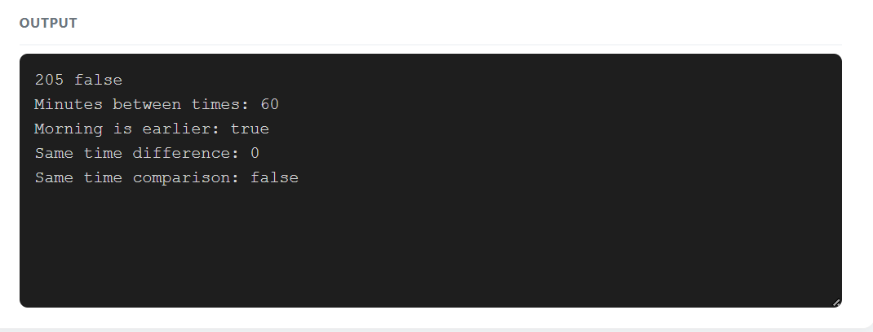
DAY-4 DESIGN CHALLENGE
Q7 – Diagnose, Redesign and Validate 13 Marks
Bloom’s Level: K5 – Evaluate
Review the evidence you generated while working on Q1–Q6. Select ONE program that shows a significant limitation as the data grows or the requirement changes.
You are not permitted simply to replace your code with a library facility and claim it is better. You must understand the problem first and then develop an appropriate redesign.
A. Diagnose the Limitation – 2 Marks
Using your own evidence, identify where the design fails or slows down and which characteristic of the original design causes it.
Evidence Expected
A precise diagnosis supported by evidence from your original program.
B. Define the Design Objective – 2 Marks
State a measurable objective for the redesign.
Evidence Expected
A clearly stated objective derived from the identified limitation.
C. Design the Revised Solution – 4 Marks
Explain what you have changed in the class or function design, which C++ feature you use, whether extra memory is needed, and any new trade-off. Provide a class diagram or pseudocode.
Evidence Expected
A coherent redesign directly addressing the diagnosed limitation.
D. Predict Before Implementing – 1 Mark
Predict the improvement and the measure in which you expect it.
Evidence Expected
A clear, testable prediction.
- Implement and Validate the Redesign – 2 Marks
Compare Original → Redesigned using the same tests and measurements.
Evidence Expected
Comparable evidence for both versions.
- Defend the Final Design – 2 Marks
Evaluate whether the objective was achieved, new costs, and where the original may still be preferable. A redesign that does not outperform the original is not automatically unsuccessful if you correctly explain why.
Code:
#include <iostream>
using namespace std;

class SavingsAccount {
private:
long long accountNumber;
double balance;
double transactions[10];
int count;
int start;

public:
SavingsAccount(long long accNo, double amount) {
accountNumber = accNo;
balance = amount;
count = 0;
start = 0;
}

void addTransaction(double amount) {
int position;

if (count < 10) {
position = (start + count) % 10;
count++;
} else {
position = start;
start = (start + 1) % 10;
}

transactions[position] = amount;
}

void deposit(double amount) {
if (amount <= 0) {
cout << "Invalid deposit" << endl;
return;
}

balance += amount;
addTransaction(amount);
}

void withdraw(double amount) {
if (amount <= 0 || amount > balance) {
cout << "Invalid withdrawal" << endl;
return;
}

balance -= amount;
addTransaction(-amount);
}

void miniStatement() const {
cout << "\nAccount Number: "
<< accountNumber << endl;

cout << "Current Balance: Rs "
<< balance << endl;

cout << "\nLast 10 Transactions:\n";

for (int i = 0; i < count; i++) {
int position = (start + i) % 10;

if (transactions[position] >= 0) {
cout << "Deposit: Rs "
<< transactions[position] << endl;
} else {
cout << "Withdrawal: Rs "
<< -transactions[position] << endl;
}
}
}
};

int main() {
SavingsAccount account(123456, 10000);

for (int i = 1; i <= 12; i++) {
account.deposit(100 * i);
}

account.miniStatement();

return 0;
}

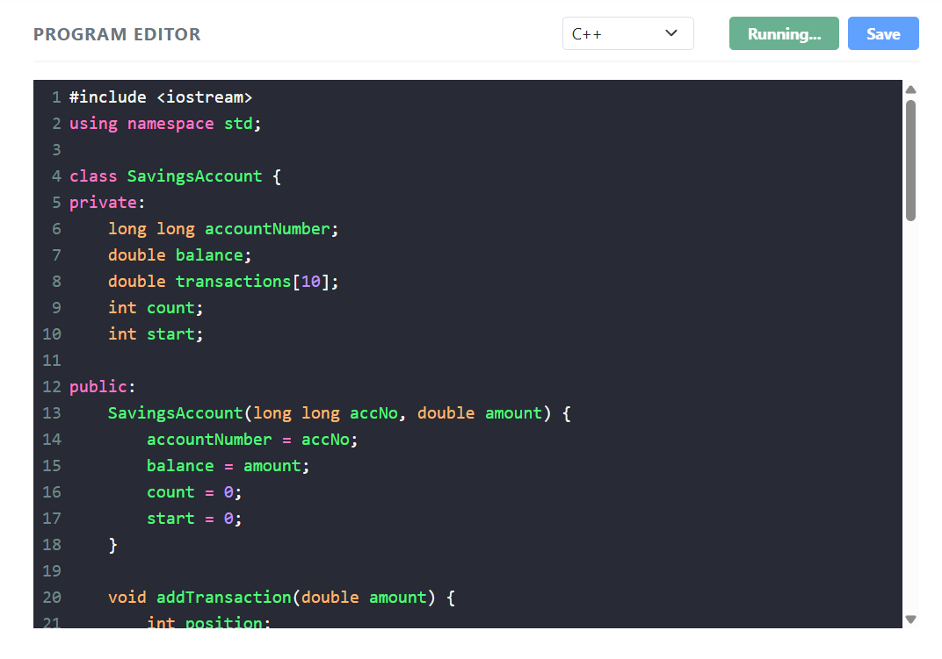
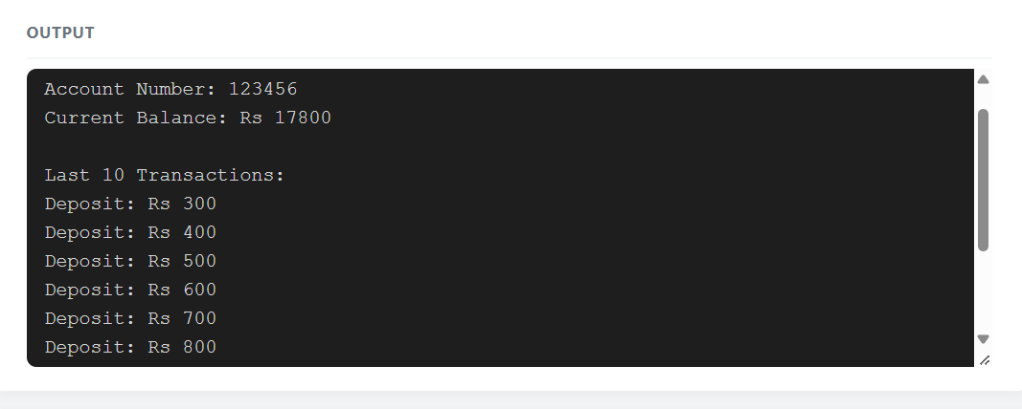

Submission Requirements
GitHub repository link (mandatory) containing the executed code for every task, including every completed “Complete the Code” program, with input files, output screenshots and a
README.md.
- Your assignment report containing the required evidence for Q1–Q7
- C++ source code for all programs
- Predictions, outputs, timings and compiler messages used as evidence

Assessment Verification
Students may be asked to explain any part of their predictions, code, tests or results during a brief verification discussion/viva.

